Amazon Virtual Private Cloud(VPC)

**Implementing Scenario**

You can use the VPC wizard to create the VPC, subnets, and NAT gateway for scenario 2. You must specify an Elastic IP address for your NAT gateway; if you don't have one, you must first allocate one to your account. If you want to use an existing Elastic IP address, ensure that it's not currently associated with another instance or network interface. The NAT gateway is automatically created in the public subnet of your VPC.

**To allocate an Elastic IP address**

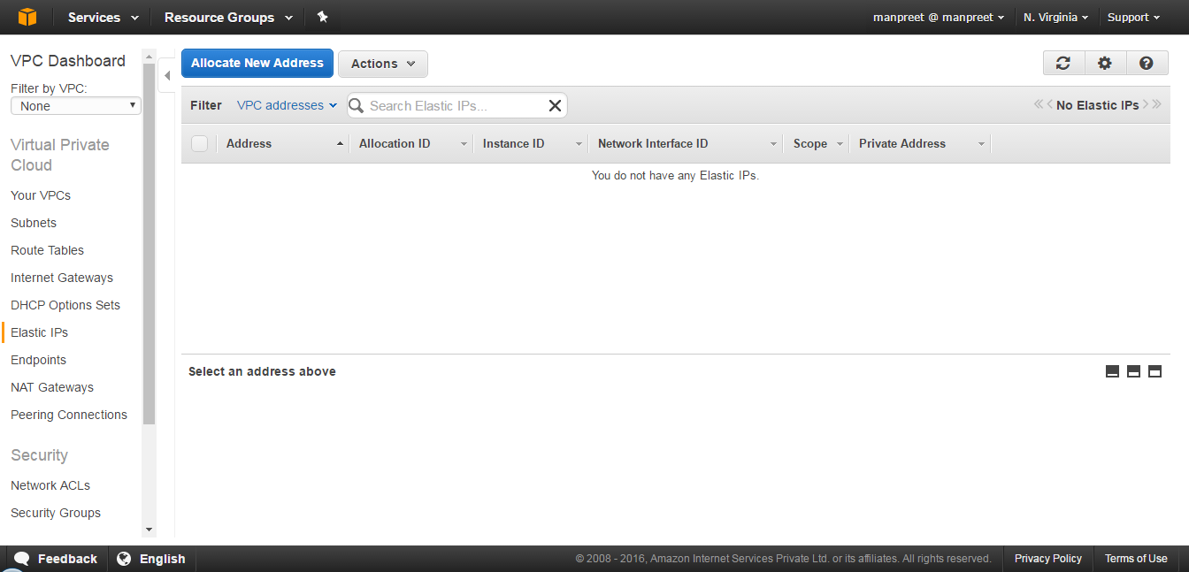

Click Allocate New Address:

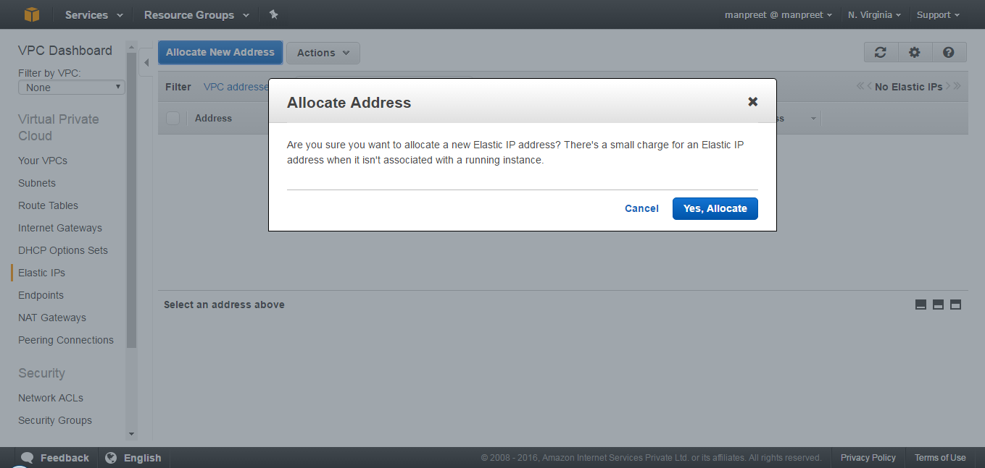

Click Yes, Allocate

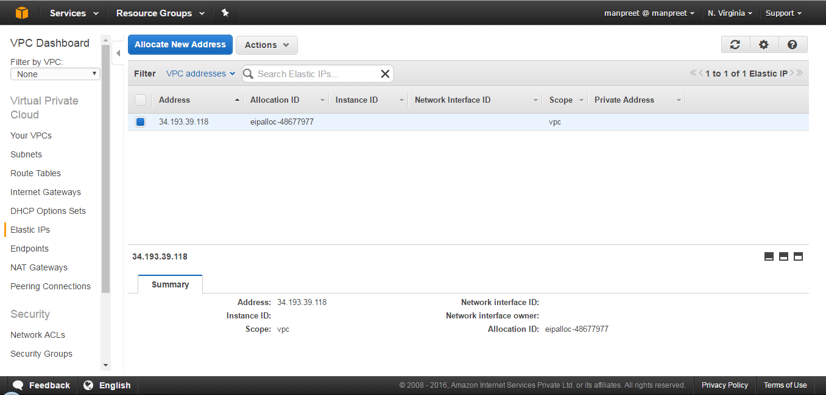

**To create a VPC with a NAT gateway**

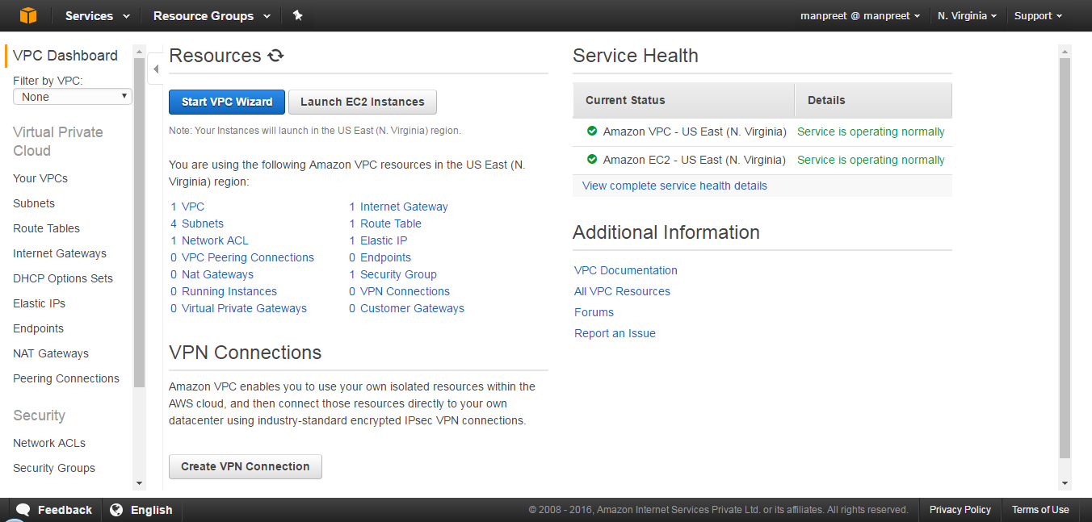

Click Start VPC Wizard:

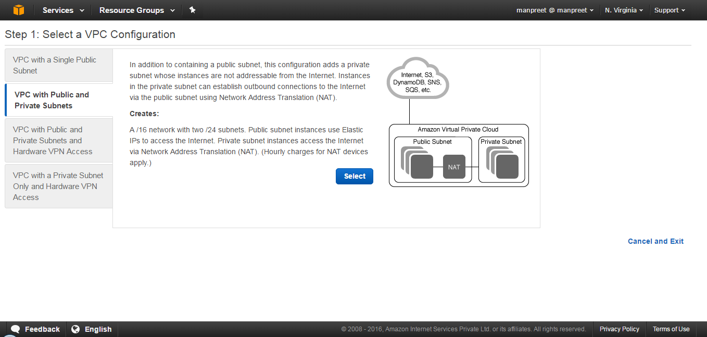

Click Select:

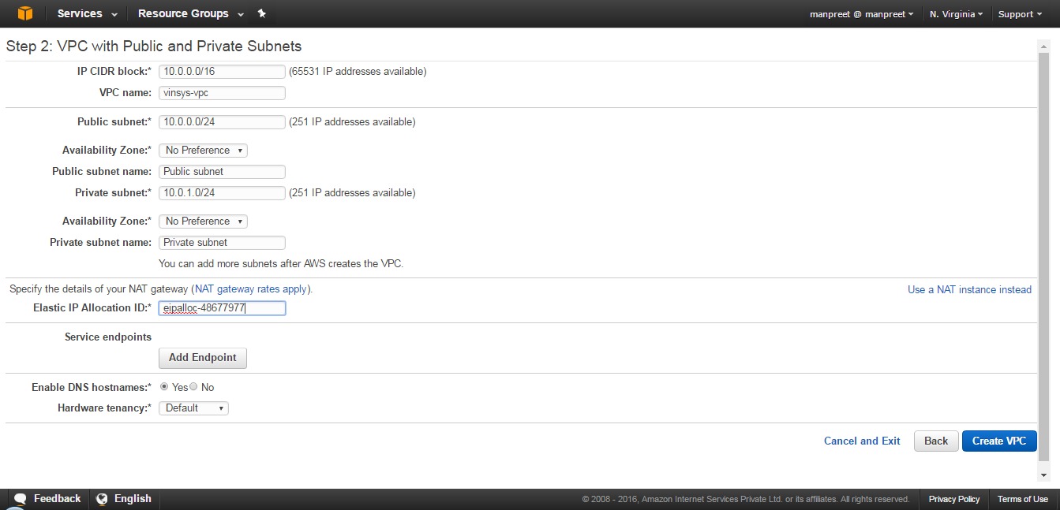

**Note:**

Private & Public Subnet should be in different zones(Mandatory), without the mysql subnet group won't be created.

By default No Preference option, will create both the subnet in same availability zone.

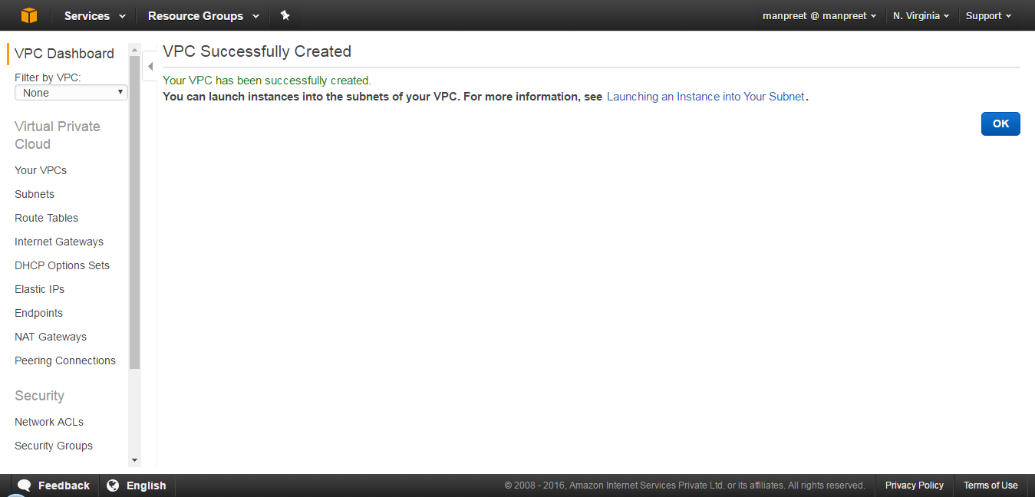

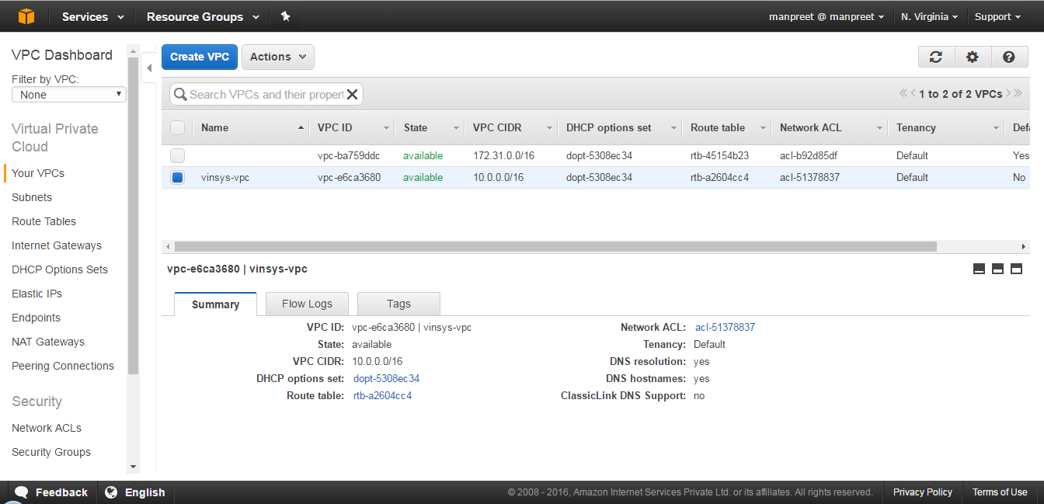

Select Subnets:

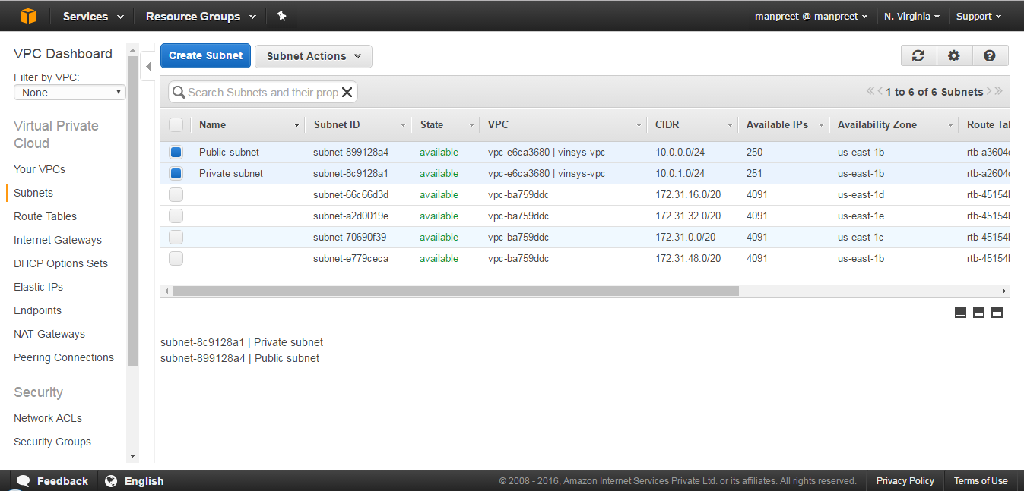

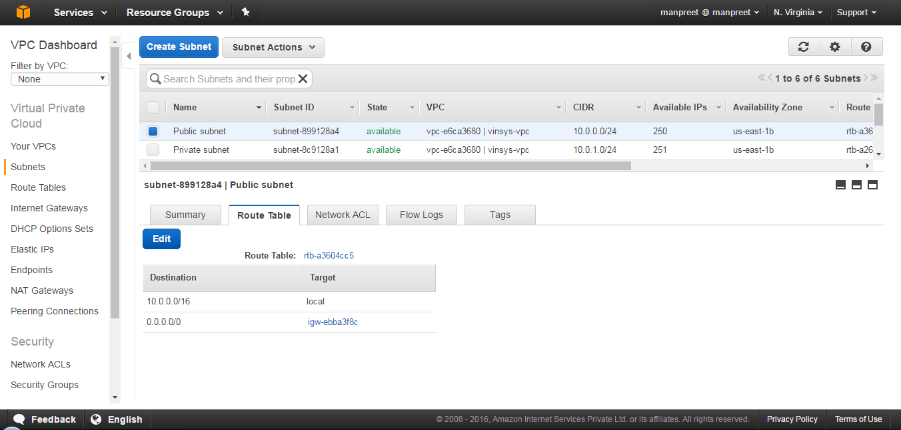

or (Should be in different zone, observe Availability Zone)

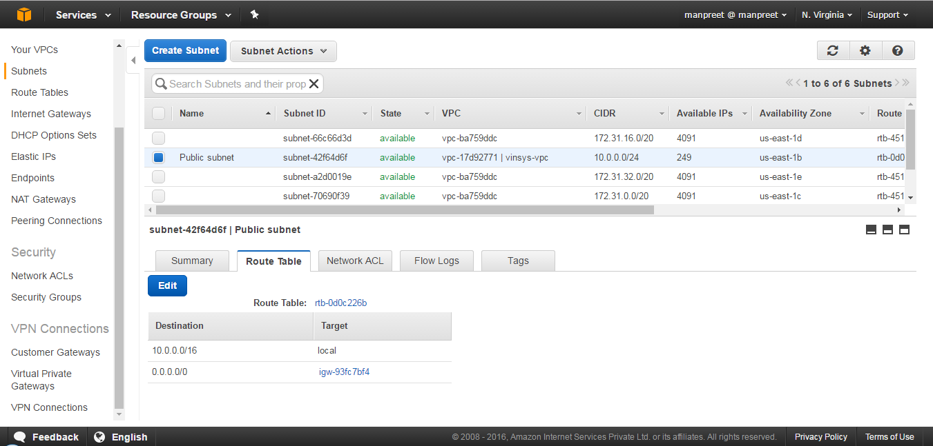

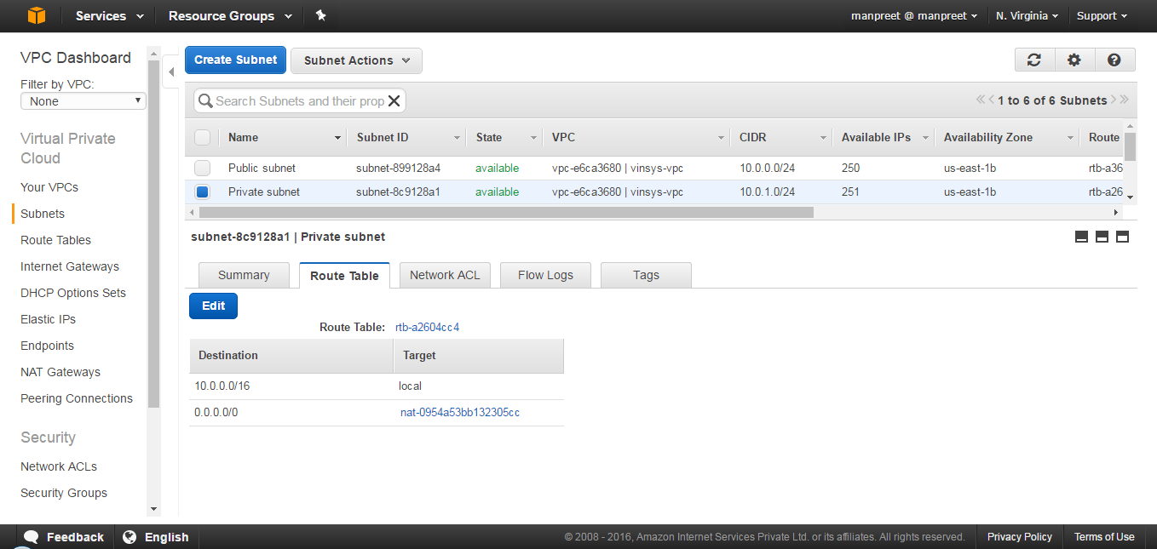

or (Should be in different zone, observe Availability Zone)

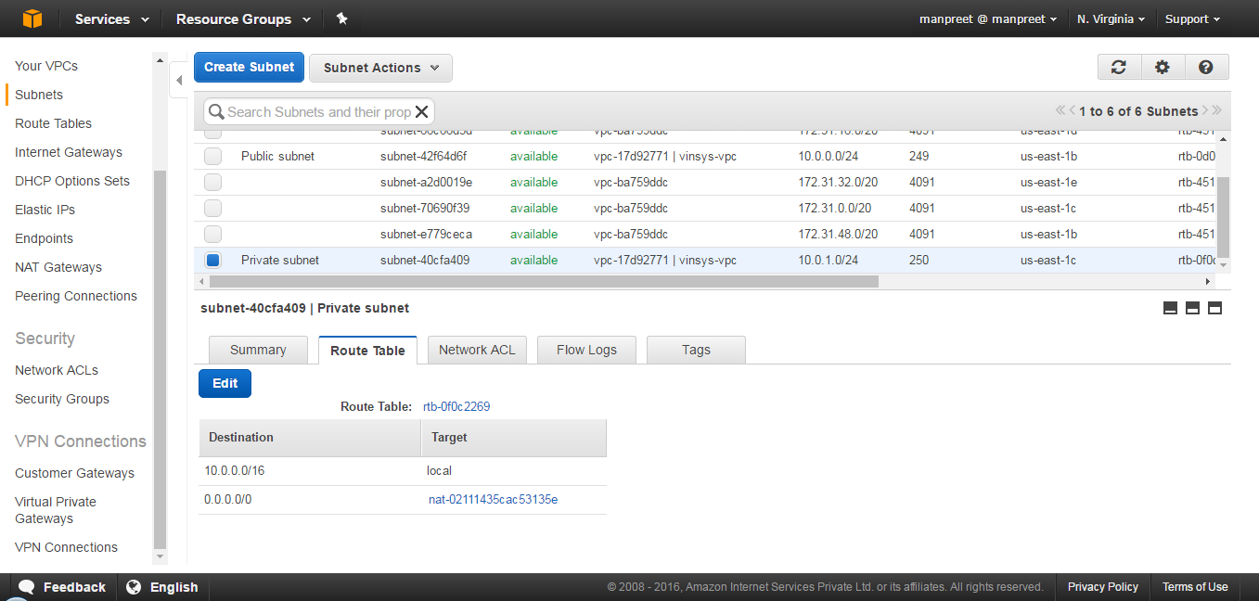

Select Route Tables:

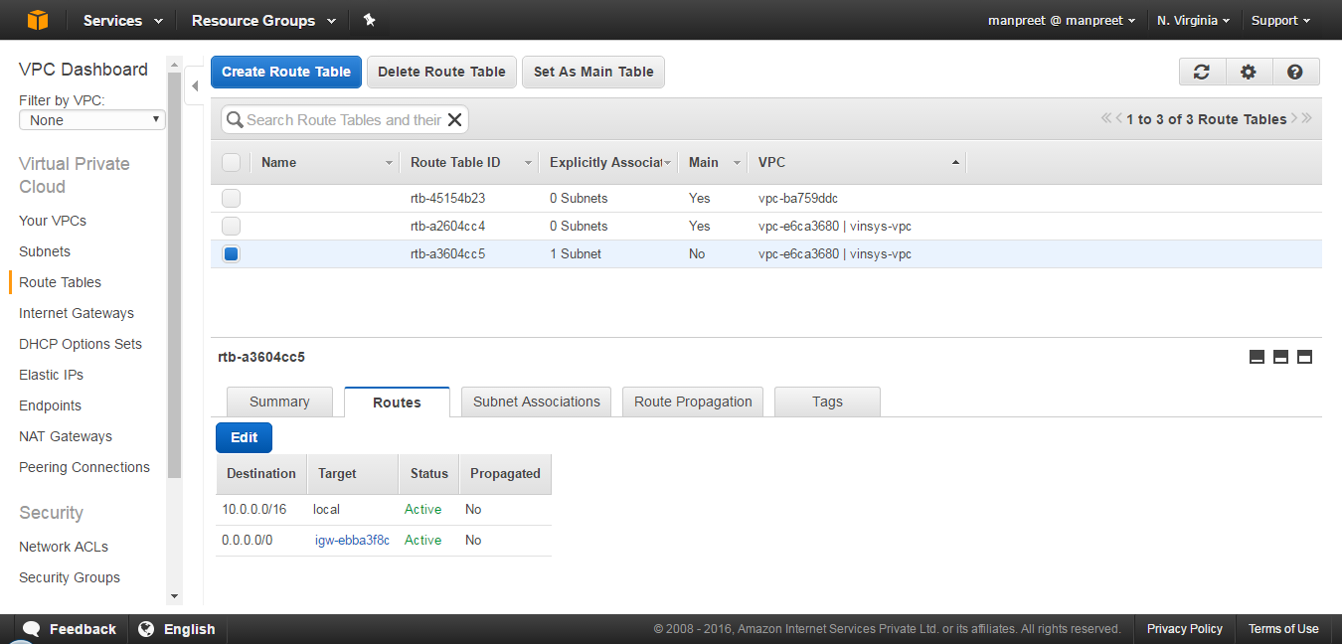

Select Internet Gateways:

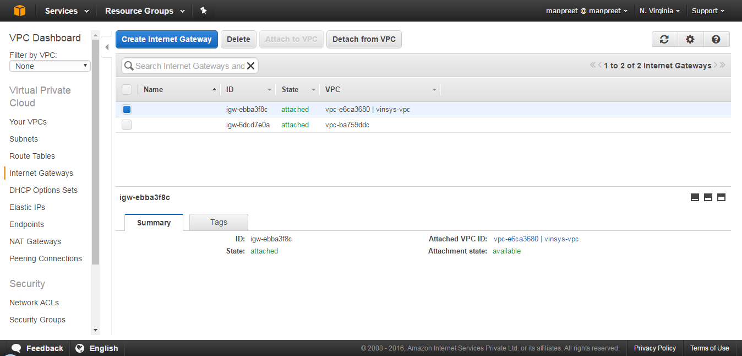

Select Elastic IPs:

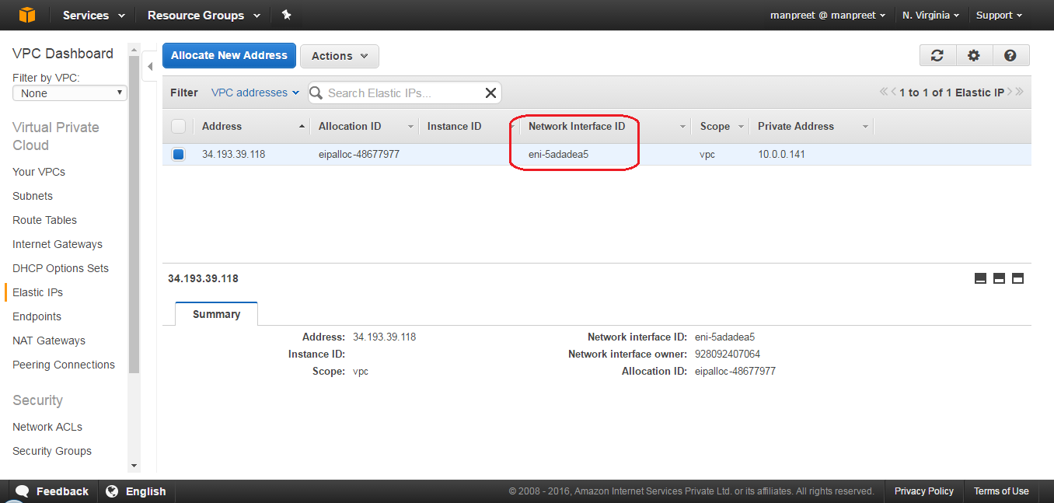

Select NAT Gateways:

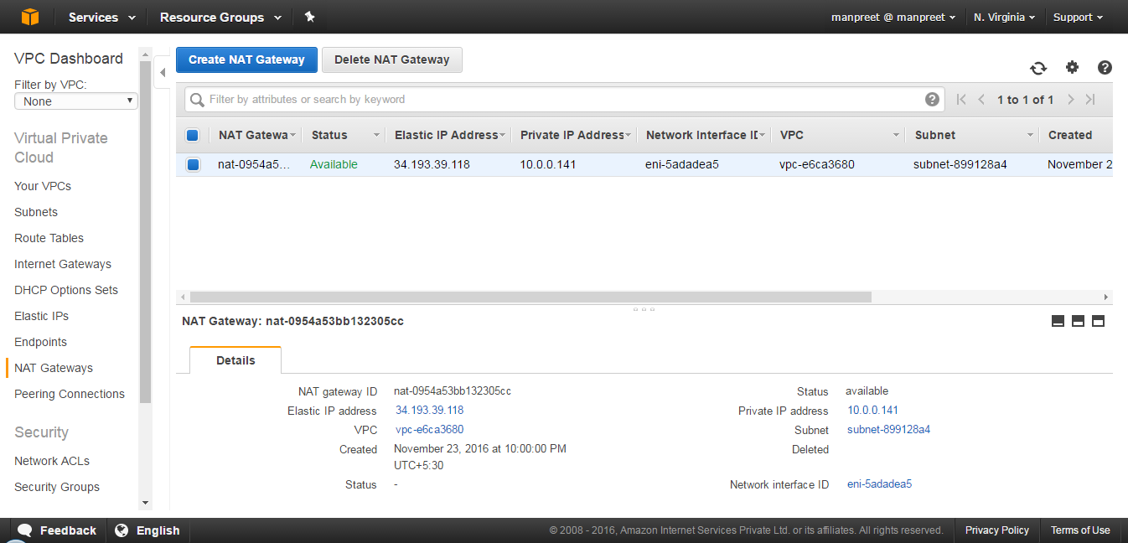

Select Network ACLs:

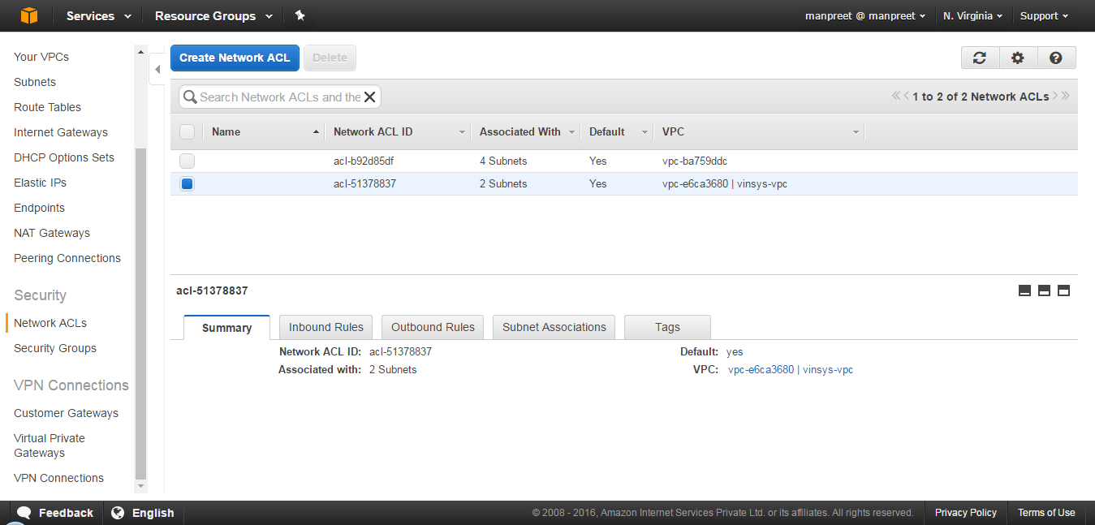

Select Security Groups:

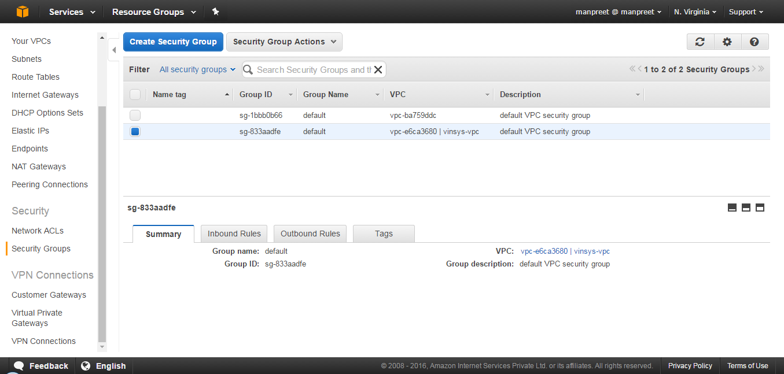

**To create the WebServerSG and DBServerSG security groups**

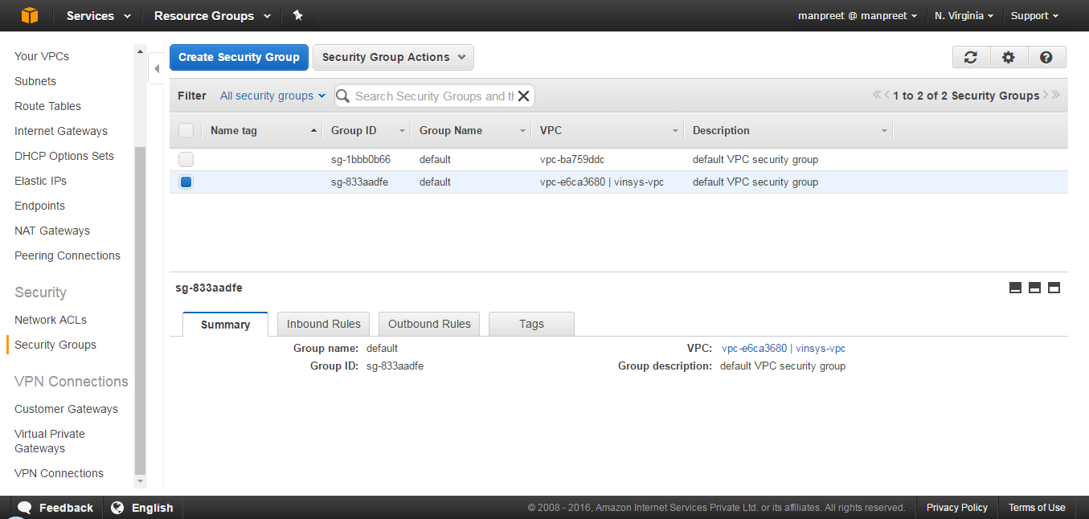

Click Create Security Group:

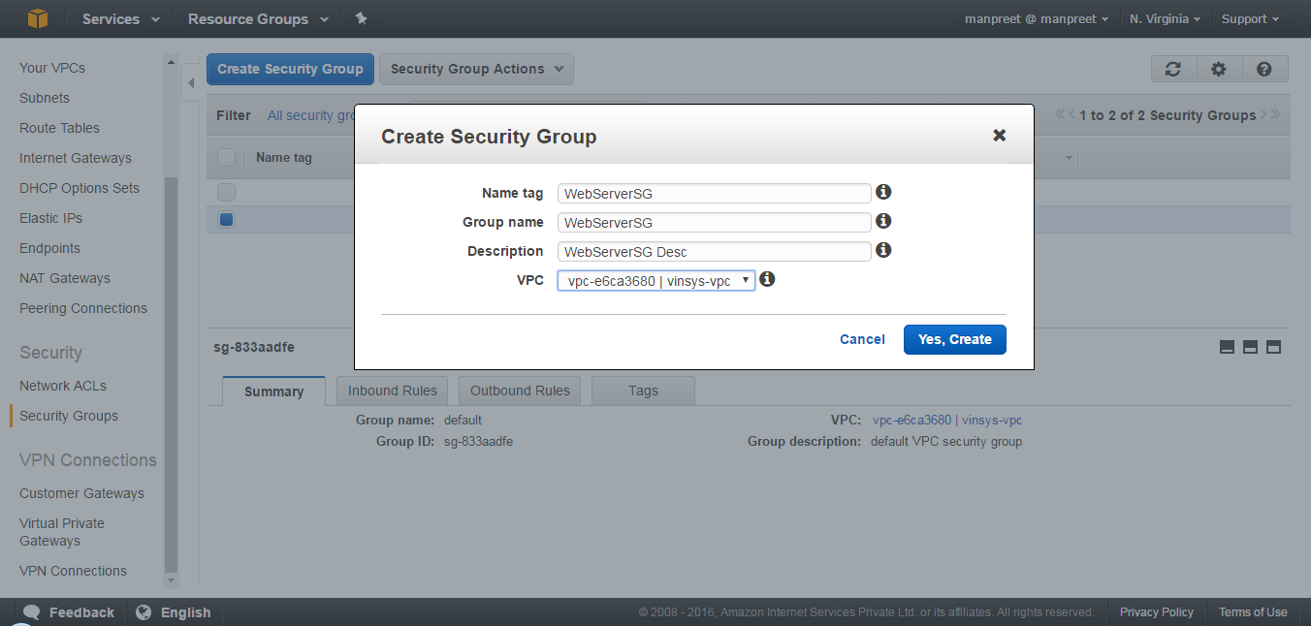

Click Yes, Create. And again Click Security Group:

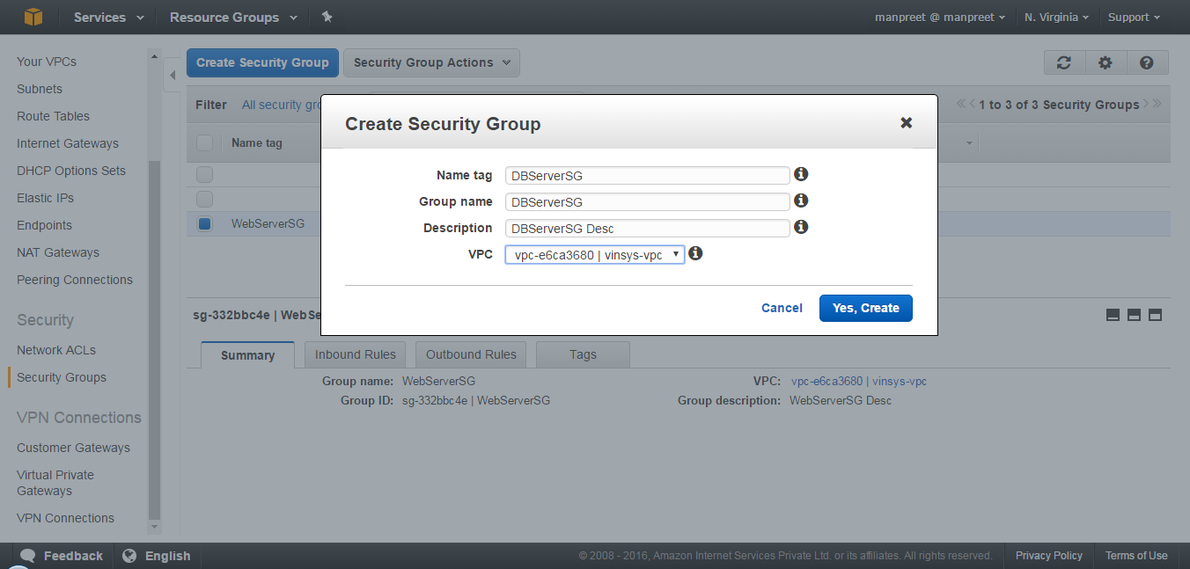

Click Yes,Create:

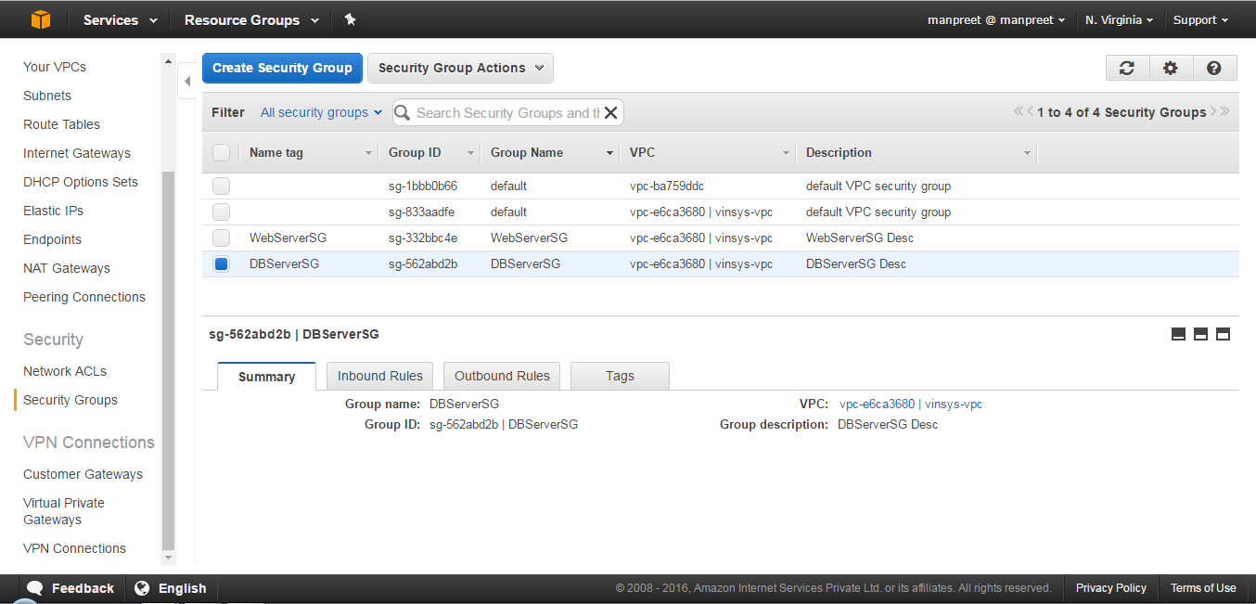

**To add rules to the WebServerSG security group**

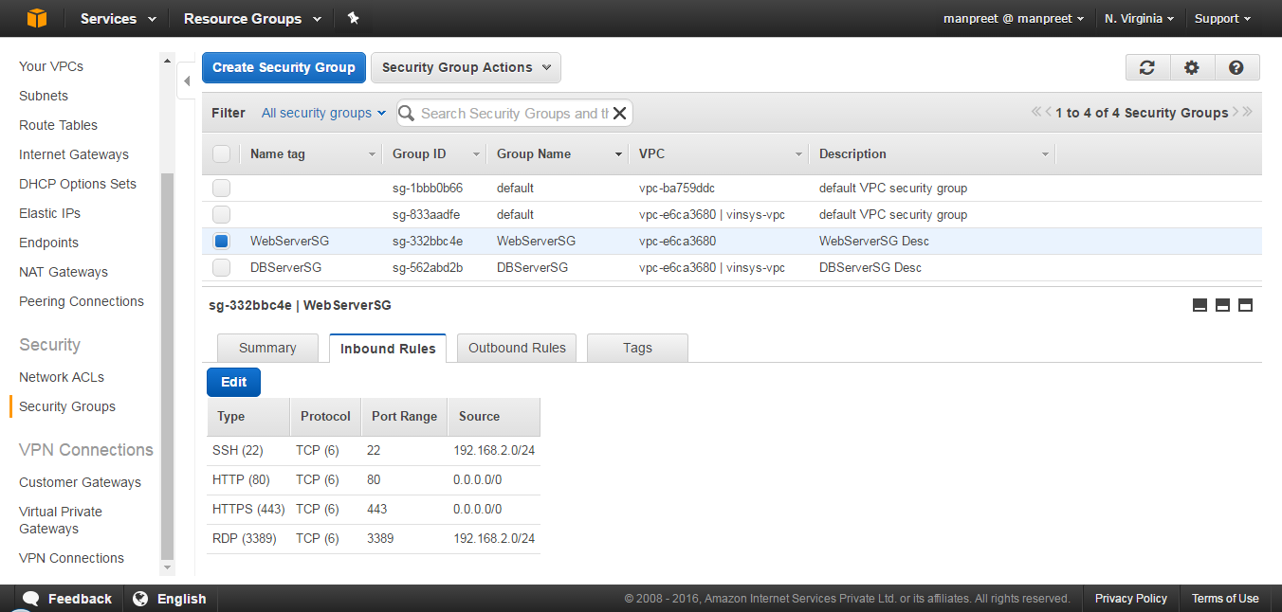

Instead of Source 192.168.2.0/24 use 123.252.203.194/32 (My IP)

Add rule, Type, MYSQL. For Source, specify the ID of your DBServerSG security group.

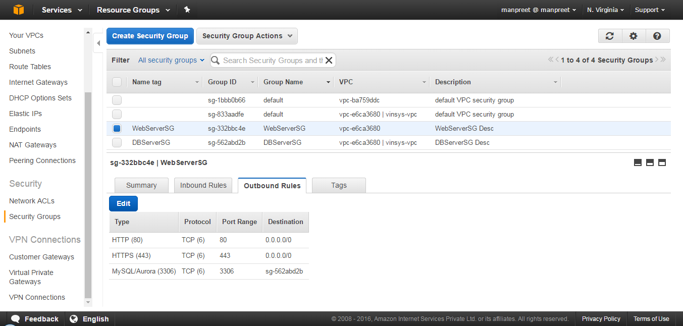

**To add the recommended rules to the DBServerSG security group**

Add rule, Type, MYSQL. For Source, specify the ID of your WebServerSG security group.

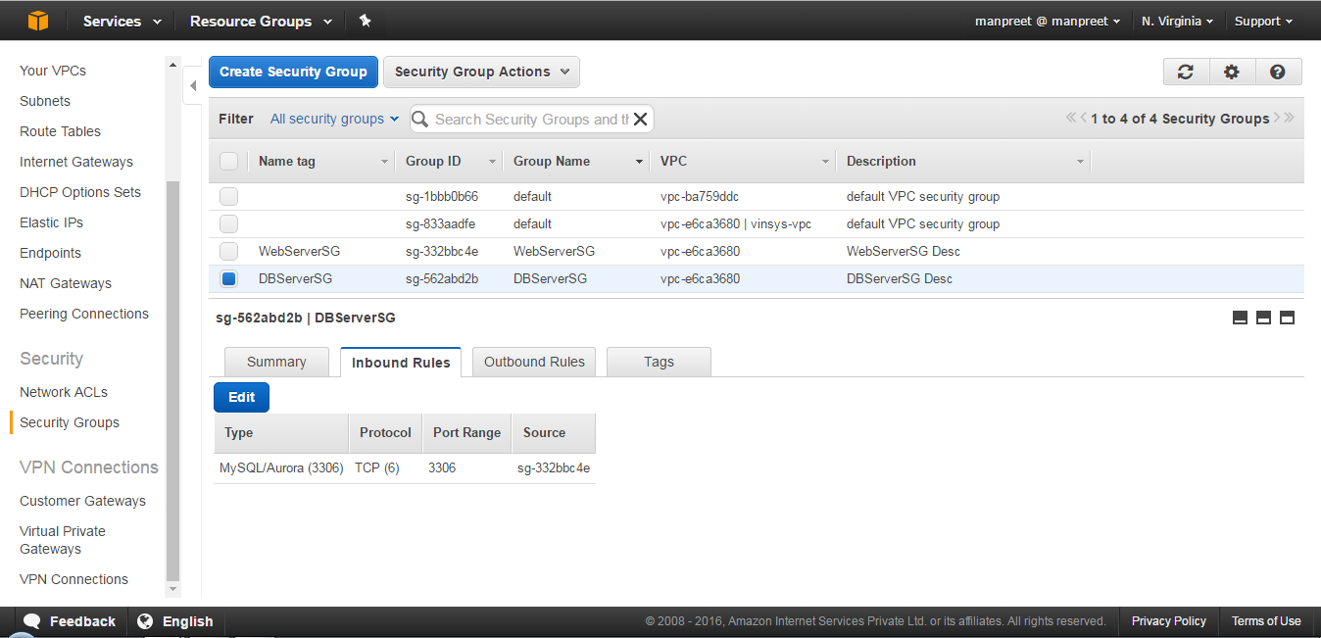

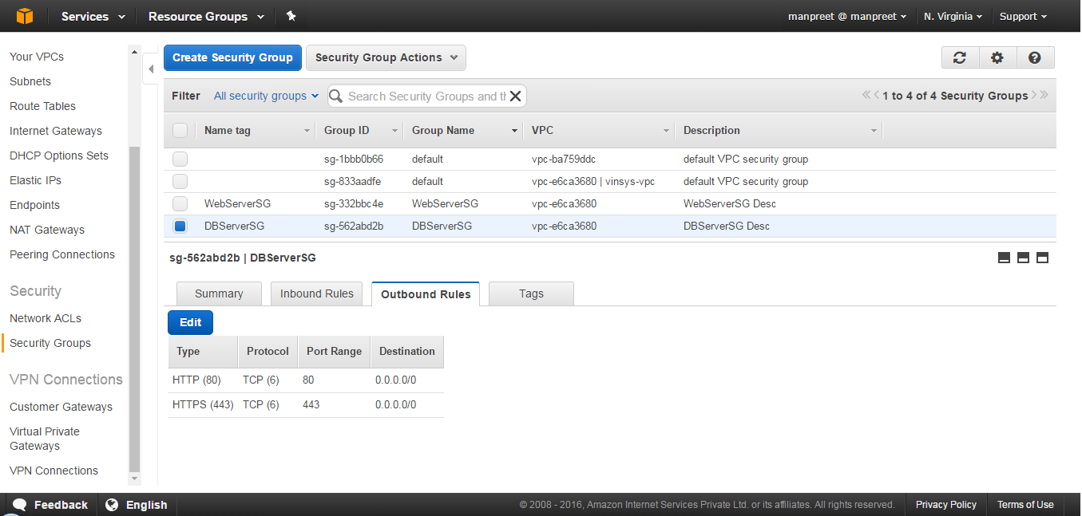

**To launch an instance (web server)**

Click Launch Instance

Select Amazon Linux AMI 2016.09.0 (HVM), SSD Volume Type - ami-b73b63a0 instance

Choose an Instance Type

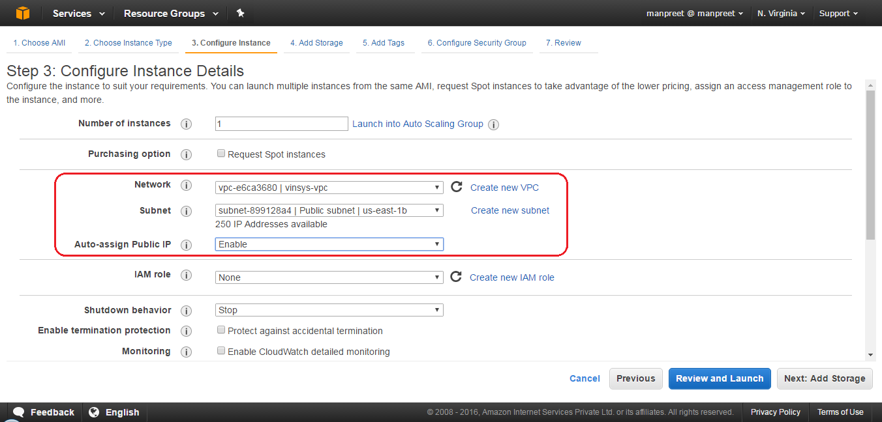

Step 4: Add Storage

Step 5: Add Tags

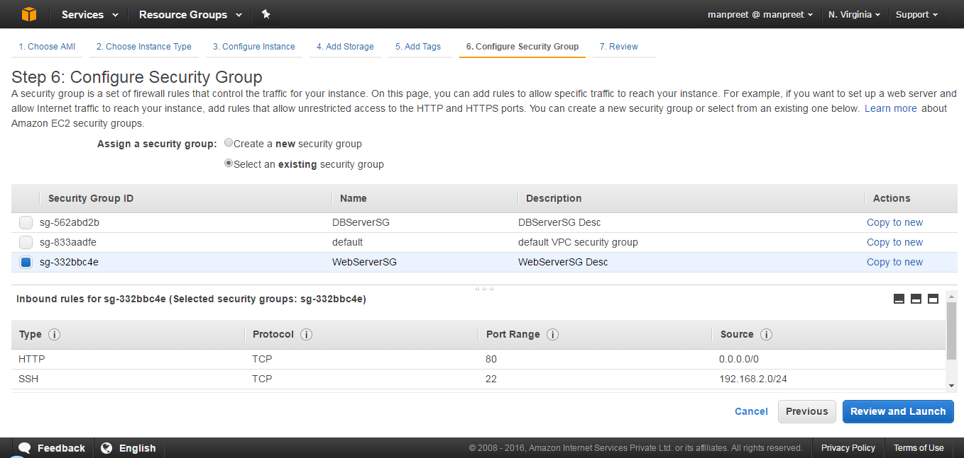

Step 7: Review and launch instances

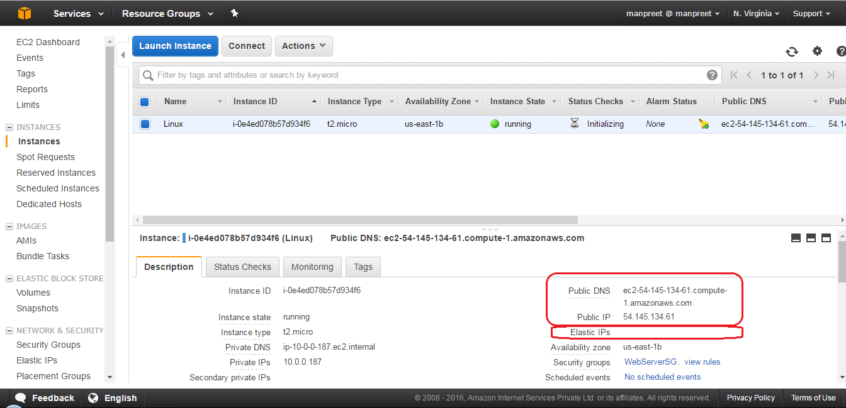

**To allocate an Elastic IP address and assign it to an instance**

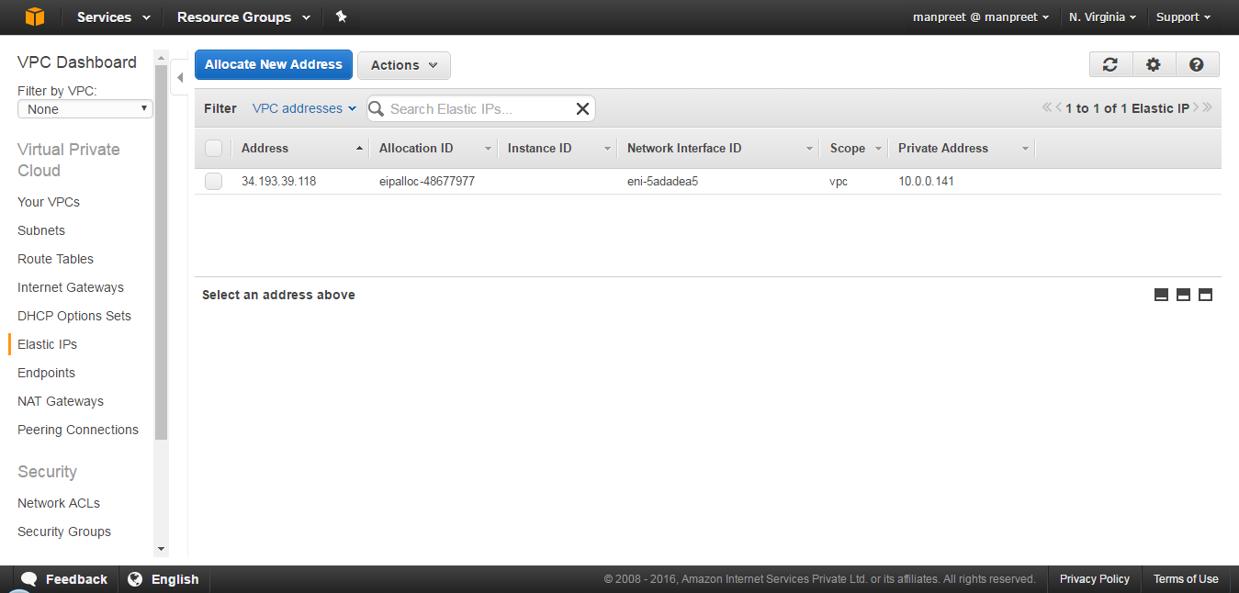

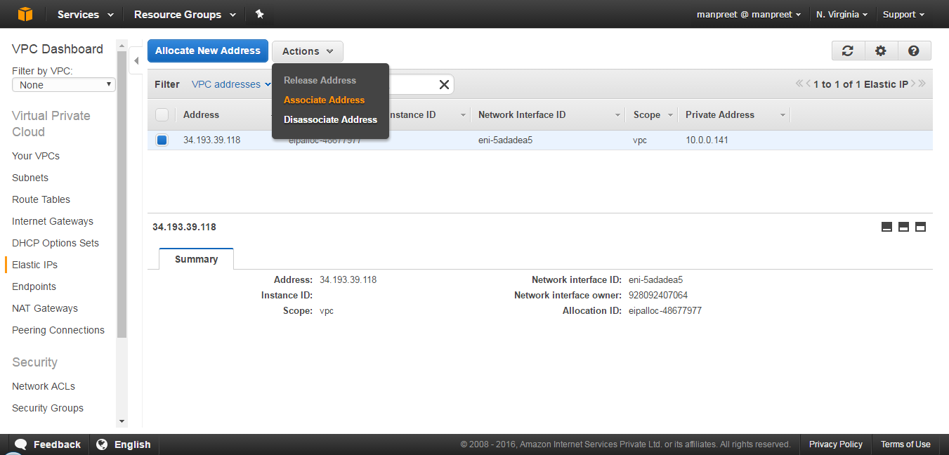

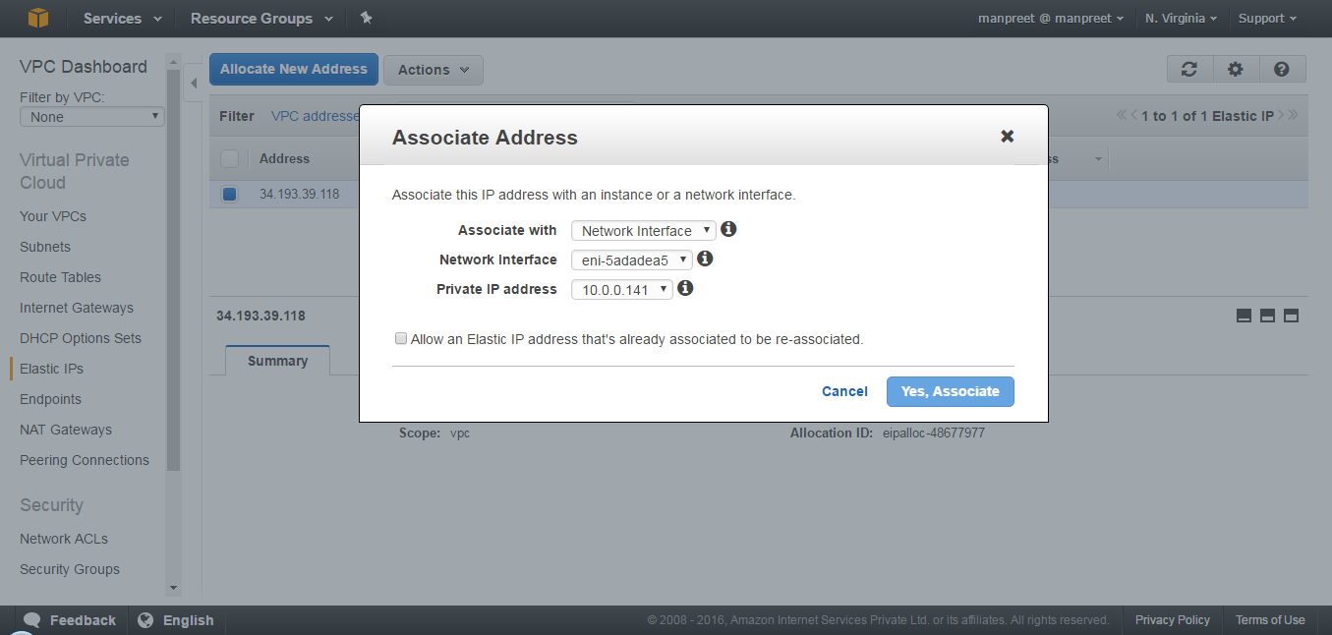

**To launch an instance (database server)**

It was found that the RDS launch wizard needs a subnet group inside when it launches a DB instance and by default it chooses a ‘default’ public subnet group of Default VPC. So, If you don’t have any custom Subnet group, you will have Default VPC’s Public -facing Subnet, launching your DB instance.

Create the Subnet group:

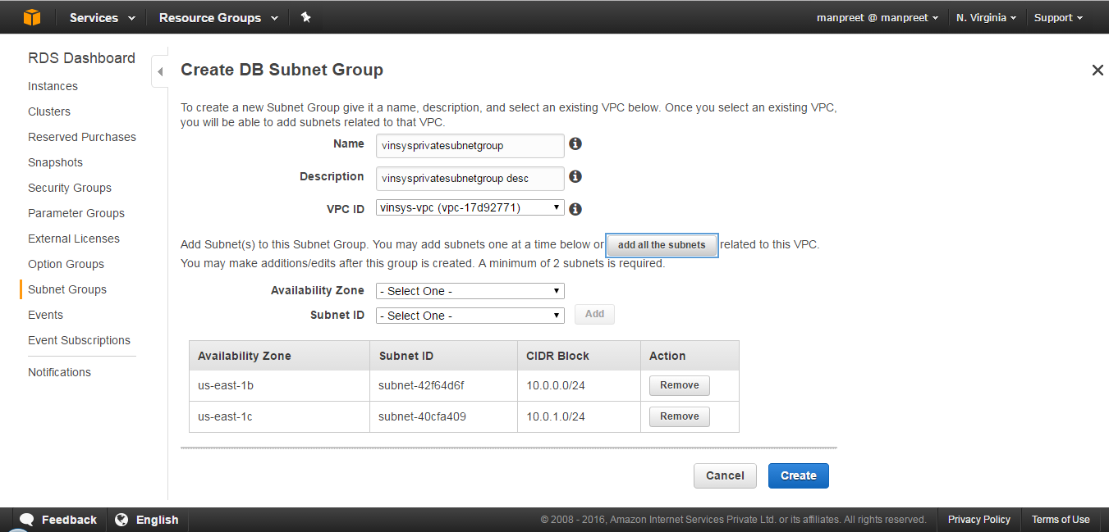

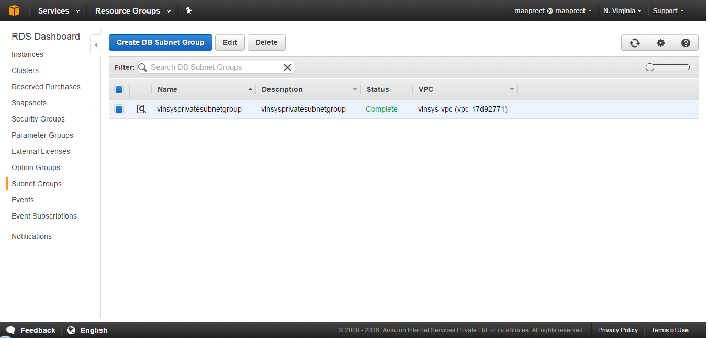

Step 1: Select Engine

Step 2: Production?

Step 3: Specify DB Details

Step 4: Configure Advanced Settings

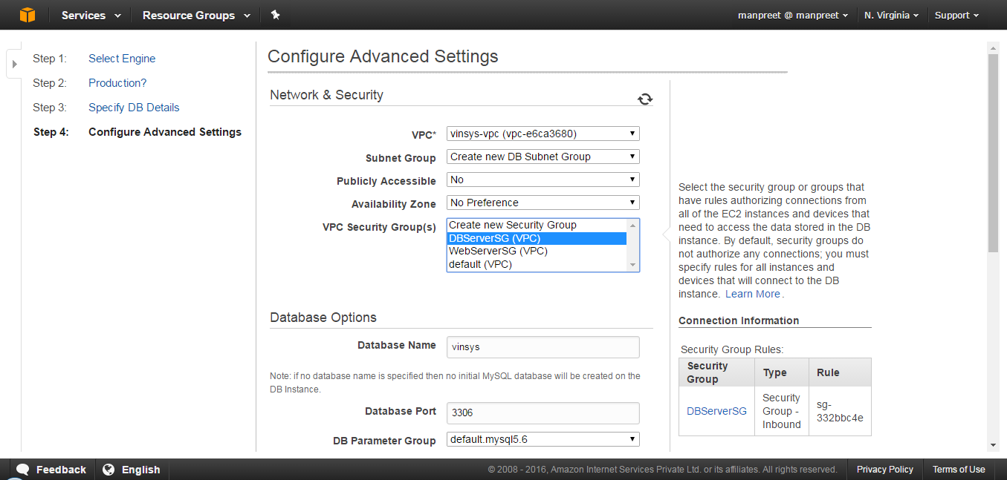

**Note:**

Select the Subnet Group created & DBServerSG VPC Security Group.

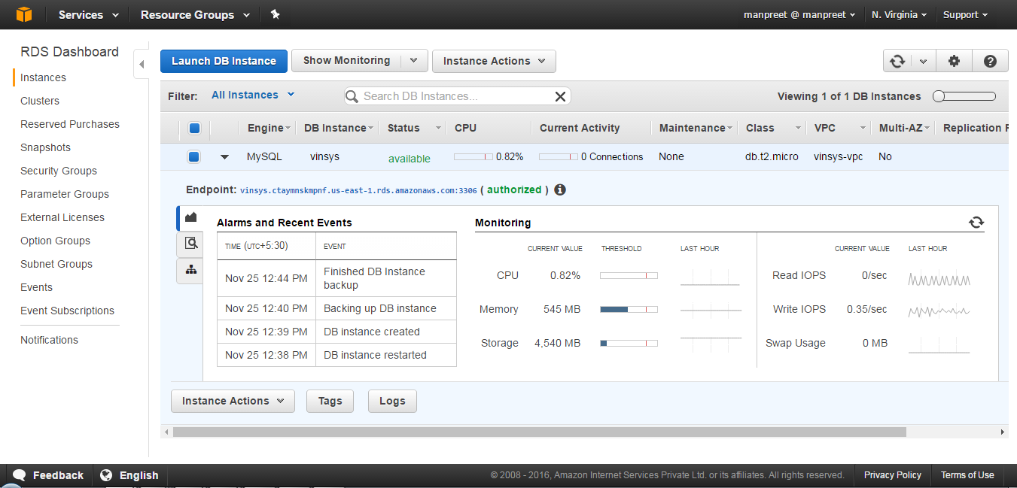

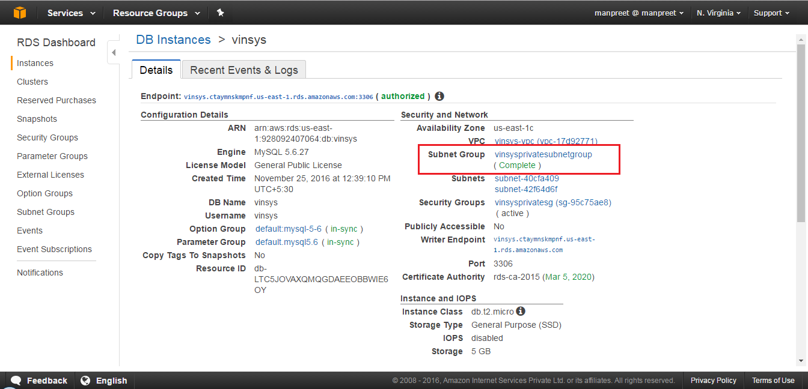

------------------------------------------------------------------------------------------------------------------------------------------

**Connect to EC2 using putty:**

sudo yum update

sudo yum install -y mysql

mysql -h vinsys.ctaymnskmpnf.us-east-1.rds.amazonaws.com -P 3306 -u vinsys -p vinsys

create table emp(

id int,

name varchar(20));

insert into emp values(1,'John');

insert into emp values(2,'Tom');

select * from emp;

commit;

--------------------------------------------------------------------------------------------------------------------

mysql -h vinsysread.ctaymnskmpnf.us-east-1.rds.amazonaws.com -P 3306 -u vinsys -p vinsys

select * from emp;

--------------------------------------------------------------------------------------------------------------------

echo ${JAVA_HOME}

${JAVA_HOME}/bin/java -version

sudo yum info tomcat7

sudo yum install tomcat7

sudoedit /etc/tomcat7/tomcat7.conf

sudo service tomcat7 start

sudo fuser -v -n tcp 8080

sudo yum install tomcat7-webapps tomcat7-docs-webapp tomcat7-admin-webapps

sudo service tomcat7 restart

Note Page doesn't render, add the Securty group for WebServer:

Security group : 8080

sudoedit /etc/tomcat7/tomcat-users.xml

sudo service tomcat7 restart

aws s3 ls

get error - assign role

aws s3 cp s3://vinsys-mybucket/WebApplication.war /tmp

sudo mv /tmp/WebApplication.war /var/lib/tomcat7/webapps/WebApplication.war

sudo service tomcat7 restart